Missionary Newsletter
  - Greater Emmanuel Temple Church
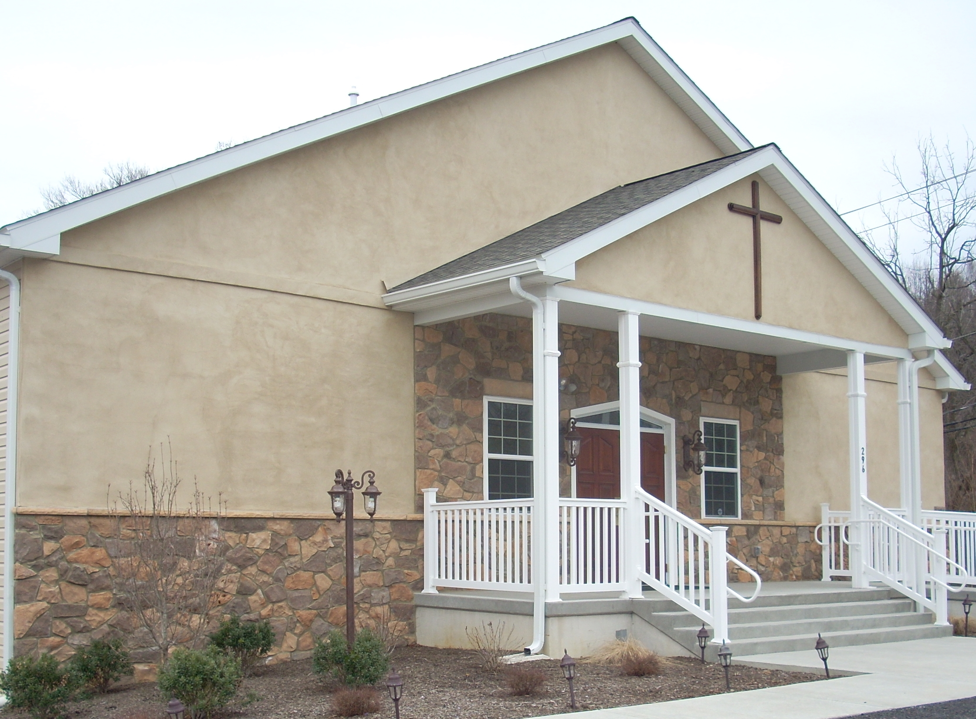
Home Missions  GETC Outreach  The Greater Emmanuel Temple (GETC) missionaries with the generosity of the members of Greater Emmanuel Temple and others were able to bless so many over the last three months.  Members of the church and community received pampers, household items, and clothing. Many thanks to our donating partner Mitzvah Circle.  Missionaries volunteered at food bank drives and clothing closets. | Transportation was provided for those who needed a ride to church or other appointments.  Food boxes were given to help members of the church and community.  Some missionaries helped deep clean the church and organize the church for our first in-person service since the pandemic on October 23, 2022.  Missionaries delivered new socks, bras, and feminine products to the Delaware Education Association’s office in Newark, Delaware in support of the homeless. | Missionaries continue to participate in the Operation Smile initiative. It is an ongoing campaign to encourage people unable to attend services or confined to their homes or facilities. Operation Smile involves a letter and or card campaign for any resident in a health facility, especially nursing homes, other centers for the elderly and the homebound. Our major goal is to bring a smile to the clients at these institutions. Dr. Stewart has started sharing Elder Glasco’s bible studies and morning prayer links with one resident with access to email!

  GETC Missionaries supported the Delaware State Episcopal Church Women -Home of the Brave Project II which helps female veterans get on their feet after traumatic experiences. Our department donated Wawa gift cards, detergent, paper towels and bath towels and wash cloths.  Home of the Brave  Serving Those Who Served  Us  Moreover, the GETC Miss-  Ionary Department financially supported a college student who needed urgent funds for her college text books.  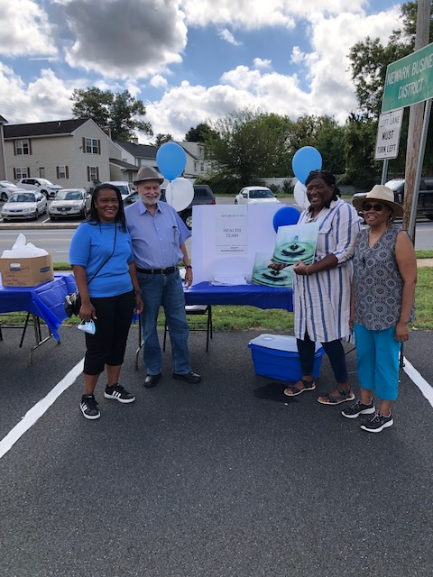  Our Missionary President Dr. Stewart, is a member of the Newark, Delaware’s NAACP Branch; she is a member of the Health and Education Equity Committees. She participated in the Health Seminar on Covid and Food,as well as the Health Fair. She volunteered at the Food Bank and the Health Committee’s table on the importance of water to our health. Dr. Stewart had her blood pressure, glucose level and other tests done by one of the vendors on site,free of charge. She believes everyone should know their health scores as a preventative measure! | 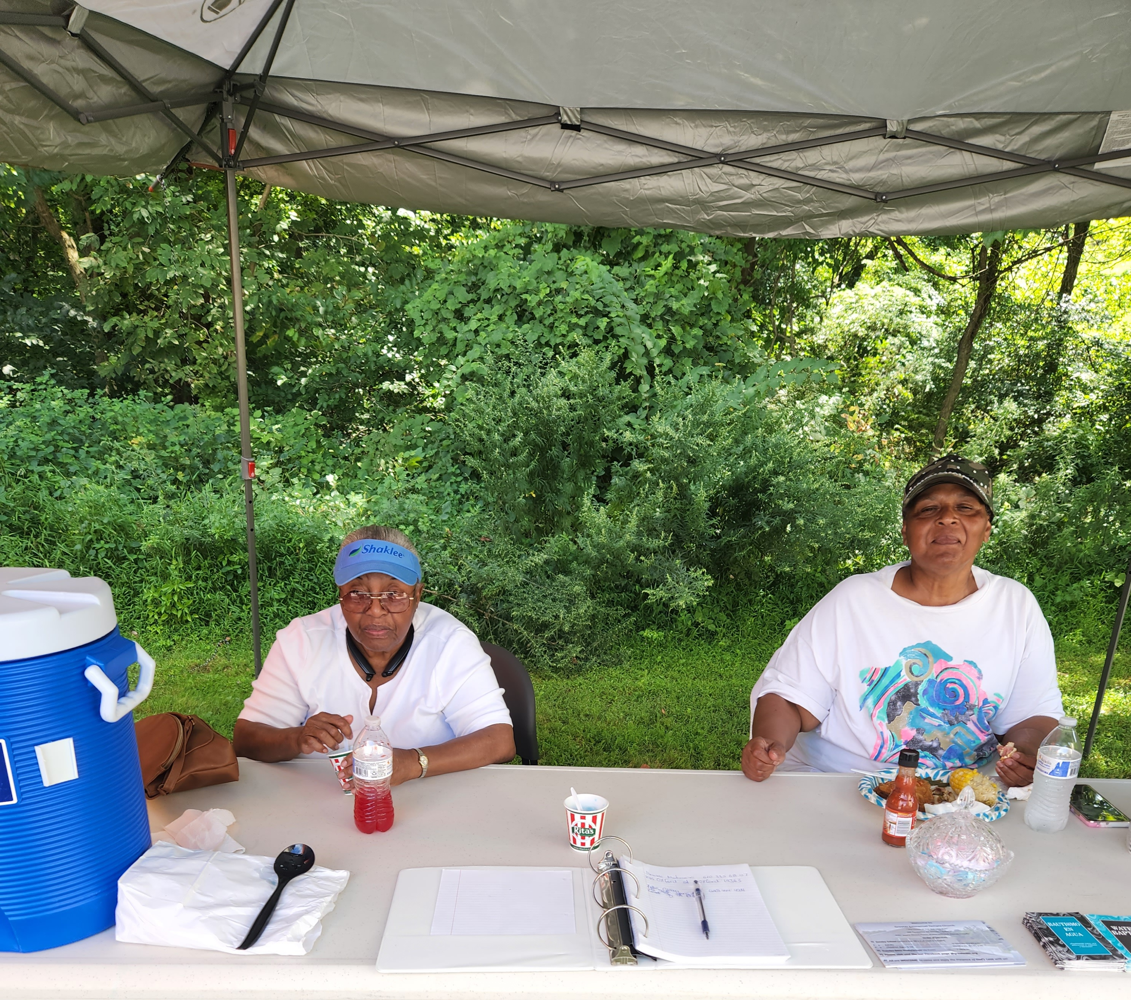  Missionaries Phyllis Devan, on the left and Anne Wood pictured above were set up at GETC’s Back to School Community Event for anyone needing prayer. A Prayer Request book and tracts were available for visitors  GlobaL Missions  GETC Outreach  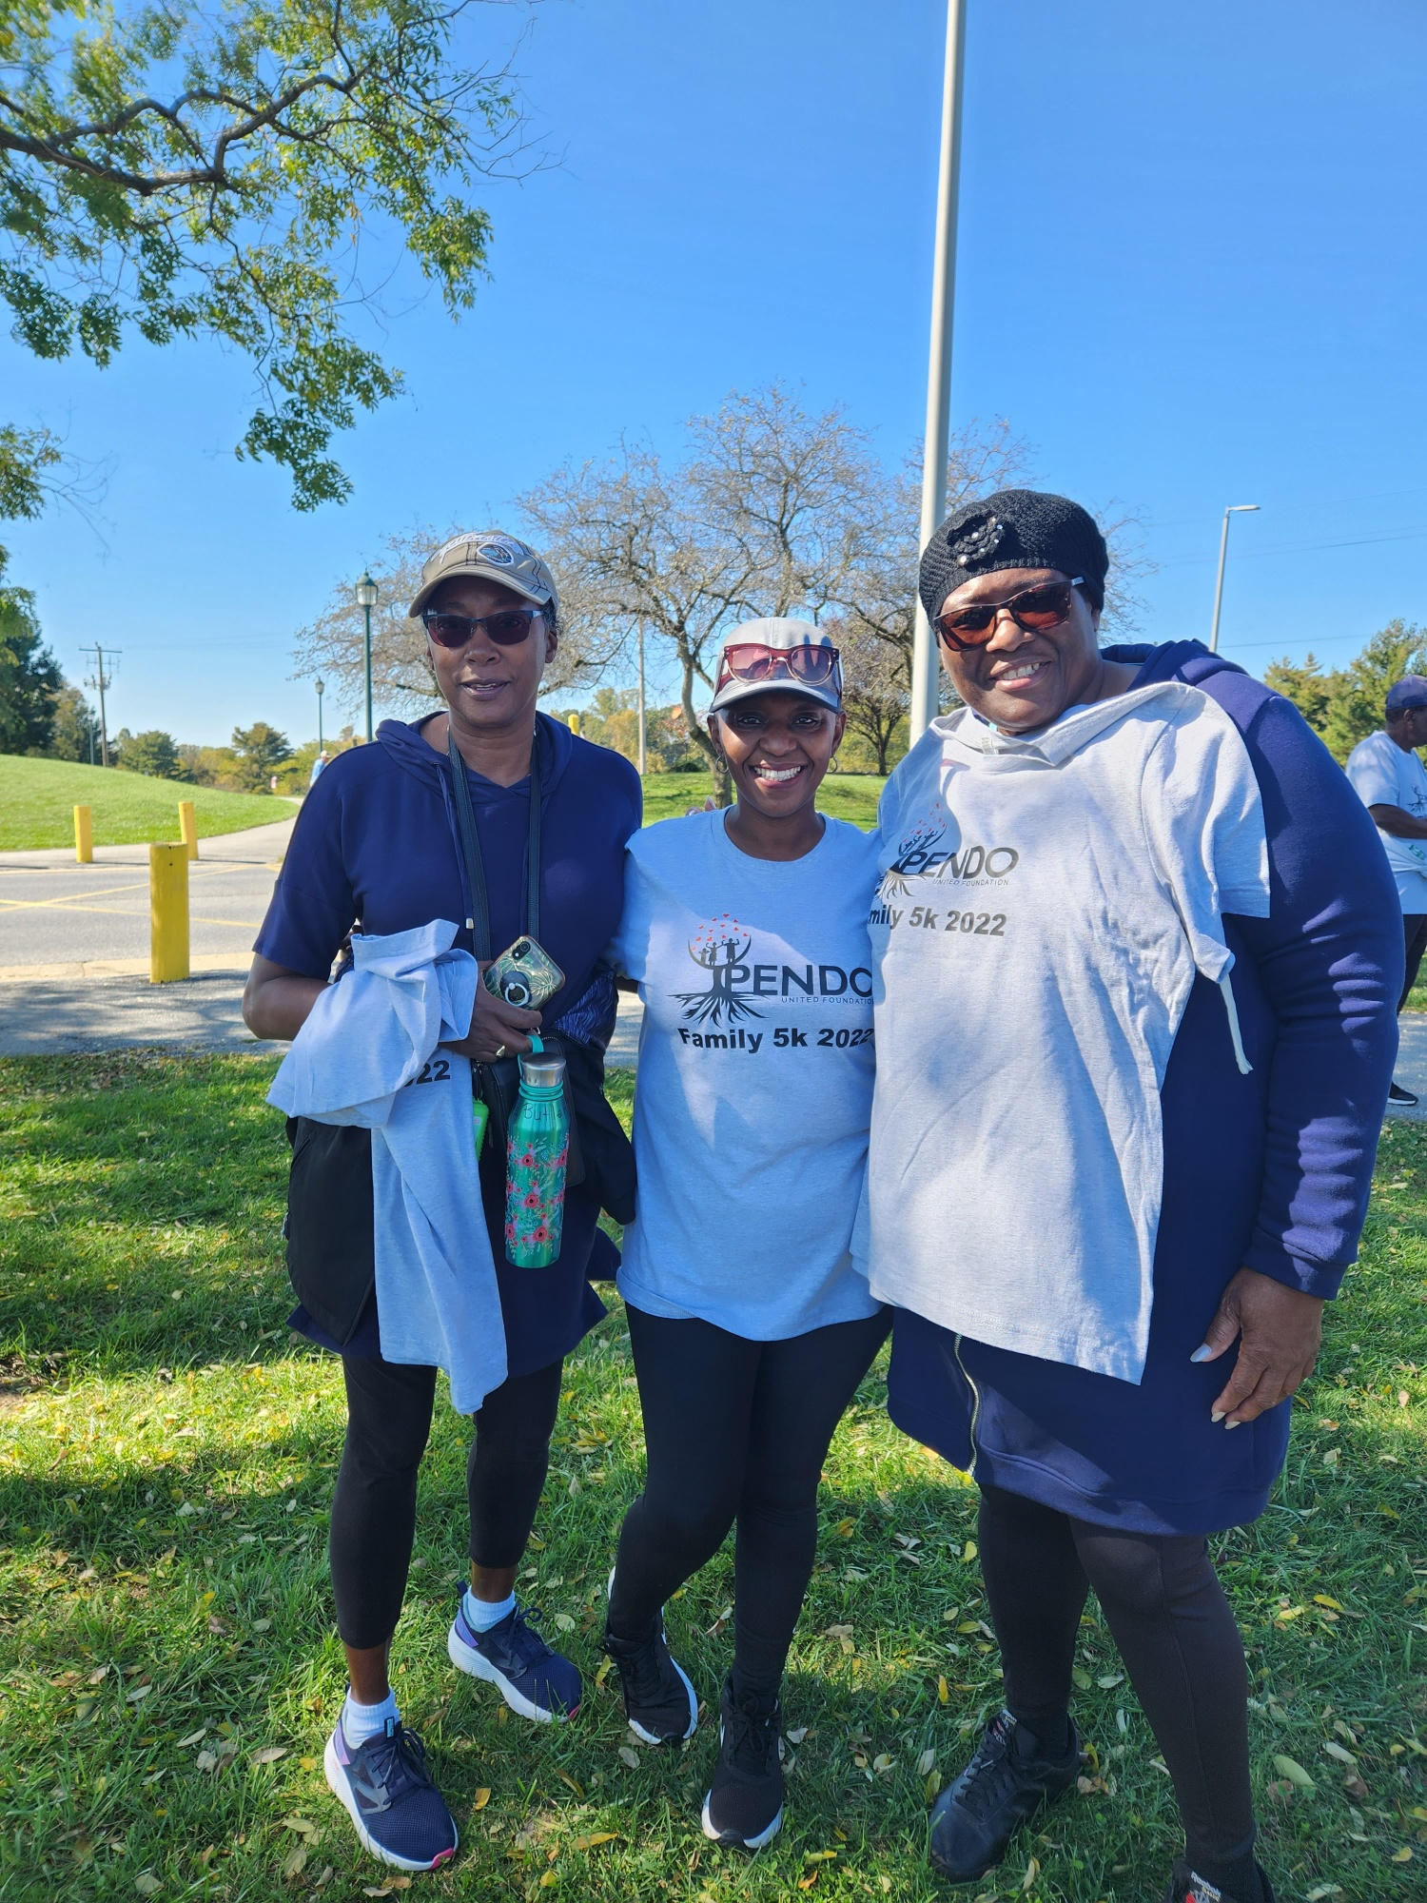  Missionary Dr. Shirley Stewart,GETC Missionary President on the left , Upendo founder, Regina Reithii in the middle and Sister Kathy Butler | pictured on the right, GETC organist pictured above at the beautiful  Delcastle Park in Wilmington, Delaware. They participated in the 5K walk held to support Upendo’s work in Kenya. GETC supports Upendo on a monthly basis as part of our global mission initiative.  Punta Canta, Dominic Republic  The International Women’s Council (IWC) of the Church of  Our Lord Jesus Christ, Inc. is preparing for a Mission Trip to Punta Cana, Dominic Republic. IWC plans to send items for the orphanage, a nursing home, and a refugee camp. Visitation to local churches are planned as well. Missionary Dr. Shirley Stewart plans to join the IWC on this mission project. She is looking for sponsors to aid her in this endeavor. Donations are tax deductible when sent to Greater Emmanuel Temple Church.noting Stewart Mission Effort.Click the following link to view her sponsor letter :DR Sponsor Letter.docx. Donations can also be forwarded to her Cash App $SAS2036 or mailed to her attention at the church address: Greater Emmanuel Temple Church, 296 Pemberton Road, Kennett Square, PA 19348. Deadline for donations is December 2, 2022.

Many thanks to the following GETC Missionaries who were instructors for our seven-week Women in the Bibles Series: Phyllis Devan, Dr. Shirley Stewart, and Anne Wood. The biblical women of study were Queen Esther, the Shunamite Woman, Sapphira, Daughters of Zelophehad, Anna, Queen Athaliah and Priscilla. The virtual Zoom sessions followed a presentation and culminating assessment format. All video recordings of the lessons and PowerPoints are available under studies and sermons on the church website: www.greateretc.org. Audio only versions of the sessions are available upon request. Contact Dr. Stewart via email getcmissionary296@gmail.com.

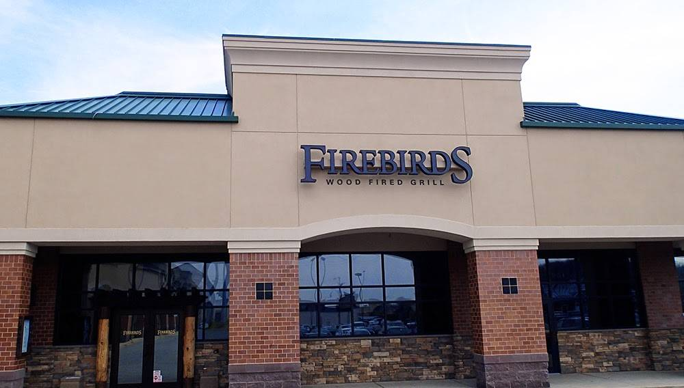
On October 22nd, the missionaries had a luncheon fellowship at Firebirds Wood Fired Grill in Newark, Delaware. It was nice to relax and enjoy a meal together!


Welcome new missionaries
GETC missionaries are elated we have new members. Sister Detra Devan will be a social missionary. Sister Kawana Stanley, Sister Kristina Washington and Sister Jayla Morris are the new junior missionaries. Dr. Stewart has implemented a mentoring program for new members. Each new mentor will be paired with a member and receive training on various duties assigned to missionaries, such as preparing for communion, foot washing and proper protocol for visiting the sick.

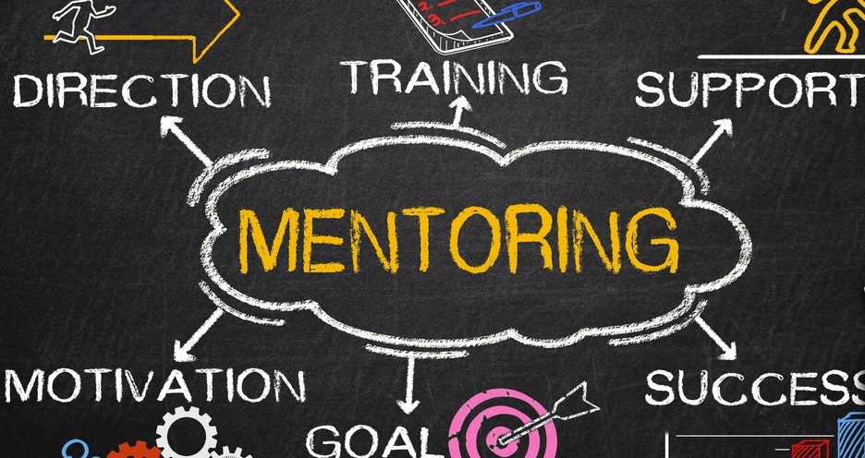

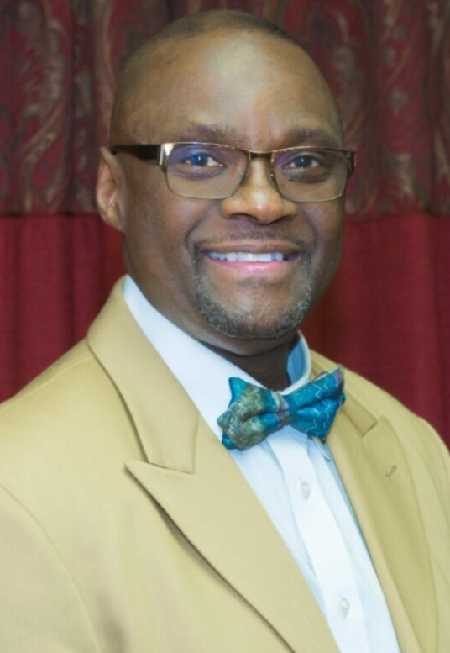
Missionary In Person Service

Wow! Great Service! Good Fellowship! It Took Me to Another Level! This is the feedback we received regarding our first in person service since the 2020 pandemic. God really blessed our guest speaker, Elder Dr. Lowell Collins from Maryland. He preached an anointed, powerful, and timely message focused on the power and authority of God’s Word and the Holy Ghost. The missionaries appreciate the support of our Diocesan Bishop Jorge Aldae and his congregation, Pastor Smith and his members, Pastor Collins congregation and visitors who supported the service. Many thanks to our sisters and brothers at GETC for preparing and serving the delicious meal to our guests. Elder Glasco for allowing us to hold the service and approving our speaker. Click the following link to view the service: https://drive.google.com/file/d/1ZHyfCwQp5SdBHQuItsjFsFl8OGp63Lt3/view?usp=drivesdk


Third Saturday
Prayer
10-12 NOON
The missionaries have commenced third Saturday prayer again! There is no doubt in our minds that prayer is essential. The bible is being fulfilled daily (Matthew 24). The duration of the prayer doesn’t determine how quickly God will hear our call. It’s the effectual fervent prayer of the righteous (James 5:16) that will bring about the much-needed change we need in the world right now. Doors will be open, pray 30 minutes, one hour or the entire two hours but PUSH- Pray Until Something Happen!

Virtual Workshop
On Monday, November 14th at 8 PM our guest speaker will be Missionary Natacha Davis of Columbia, South Carolina. She will present a session entitled: “The Qualities of a Good Missionary.” Missionary Davis is an anointed intercessor and teacher. There will be a question-and-answer period after her presentation. You may forward questions in advance to Dr. Stewart at getcmissionary296@gmail.com.
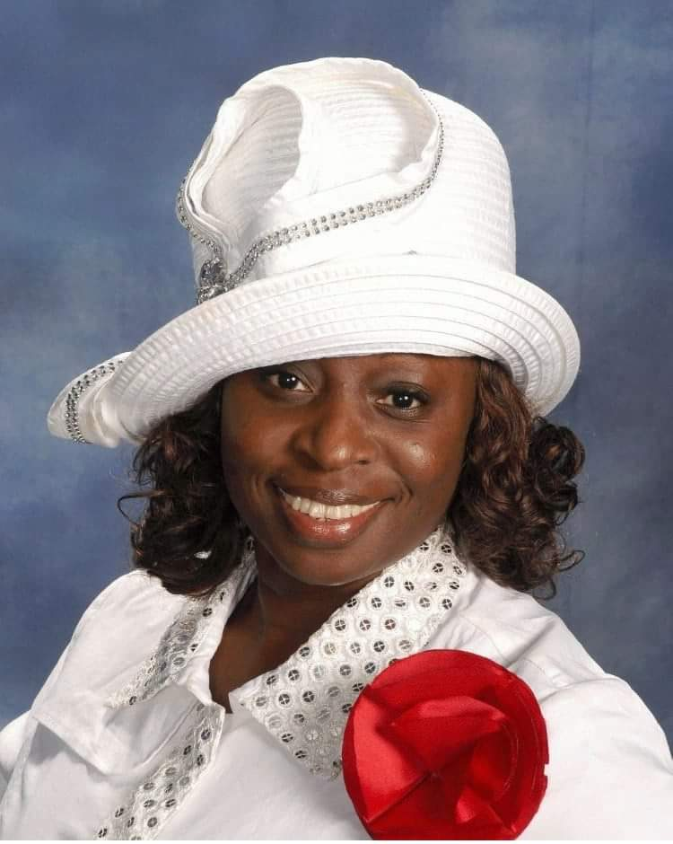
Meeting ID: 865 4516 6570

Passcode: 132120

Churchman Village Holiday Project

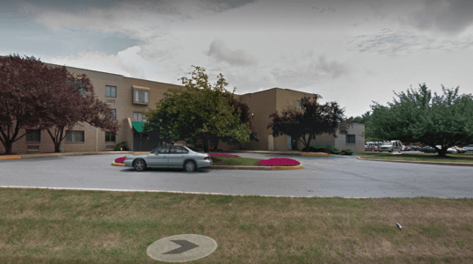
GETC Missionaries will be providing Christmas gift bags for 100 residents of Churchman Village in Newark, Delaware. Churchman Village is a senior and rehabilitative facility. Due to Covid guidelines in place, churches are not permitted to do in person programs. This is our second year of providing some cheer for the residents and staff. Ms. Shelly Funk, Activity Director, states that the seniors appreciate all the help they can receive. Their most requested items are any spiritual literature, large print word finds, puzzles, trial size lotions and other hygiene products, hats, gloves, comfortable socks, and colored pencils and or markers. You can help by donating items or providing monetary donations to support the project. Donations can be mailed to Greater Emmanuel Church, Attn: Missionary Dr. Shirley Stewart, 296 Pemberton Road, Kennett Square, PA 19348, or Cash App: $GETCpa note Missionary Project. Any questions can be sent to the following email getcmissionary296@gmail.com

All Things Mental Health
GETC Missionaries are proud to support and foster positive mental health outcomes. As we all adjust to the time shift from Daylight saving time, there is no better time to discuss the importance of sleep! Throughout our life, the amount of sleep we need to survive and thrive changes, however, one thing that does not change is that we all need good quality sleep. Good sleep hygiene is associated with overall improvements in physical and mental health. For example, sleep plays a vital role in supporting memory consolidation. Additionally, sleep is often impacted by individuals who are experiencing mental health difficulties such as depression.
Below are some tips to improve your sleep hygiene (CDC, 2022):
- Be consistent. Go to bed at the same time each night and get up at the same time each morning, including on the weekends
- Make sure your bedroom is quiet, dark, relaxing, and at a comfortable temperature
- Remove electronic devices, such as TVs, computers, and smart phones, from the bedroom
- Avoid large meals and caffeine before bedtime
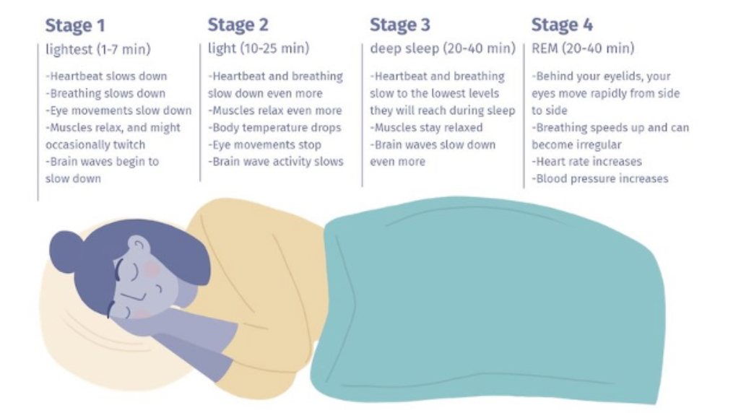
- Get some exercise. Being physically active during the day can help you fall asleep more easily at night.

Here are a few facts about the sleep cycle!

