GETC Missionary Newsletter
ISSUE
04
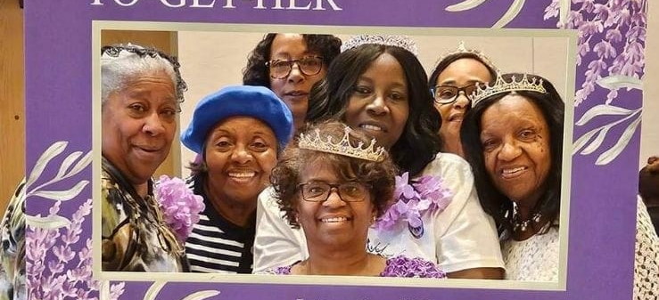
the morning business session. Moreover, she was one of the speakers for Thursday morning plenary. Her topic was Love Mercy: A Call for Equitable Treatment for ALL Winning Women. Click on the following links for part 1 and 2 of her presentation:
https://youtu.be/NfrI0yiJ7-o?si=F_ntzDY5HZ4lKPge
https://youtu.be/mgMfL4UCDqw?si=VnjXLFCCa87XUEAO
Sister Kathy Butler played and sang a wonderful medley of songs at the Social Justice Royal Luncheon. Missionary Terri Walker and Sister Kathy Butler also sang with the Mildred Washington Choir.
The 72nd IWC conference was a tremendous success. Rave reviews of a sweet sisterhood with uplifting testimonies and praises of God’s goodness and mercy.

The sisters of the Allegheny Diocese were well represented at the 72nd International Women’s Council which convened in Columbus, Ohio. The administrative theme was Winning Women G.R.O.W.I.N.G. Together ToGetHer! Pictured above are the sisters at the Royal Luncheon on Thursday, October 19th. Greater Emmanuel Temple (GETC) delegates were Missionary Dr. Shirley Stewart, Missionary Beverly Glasco, Missionary Phyllis Devan, Missionary Terri Walker, Missionary Lineada Smith and Sister Kathy Butler.
Missionary Dr. Stewart serves as the Acting Parliamentarian for the IWC. She and the Sgt.at Arm, Missionary Mary Huggins (SC) presented our 13th IWC President, Dr. Dorcas E. McCoy a purple gavel at the opening business session on Friday morning. Dr. Stewart was also responsible for the final Sunday morning
Founder’s Day
Greater Emmanuel Temple Missionaries were active participants in the preparation of our first Founder’s Day. Our establishmentarian- Apostle William F. Cramer was recognized for all of his accomplishments. The semi-formal affair was held at Mendenhall Inn banquet facilities in Mendenhall, PA.

Care Package
Our band also sent a nice care package to Jr. Missionary Kristina Washington. She is presently doing an internship at Yale University. We miss her at GETC and wanted to show her our love and support.

December
2023

Community Turkey Drive
Many thanks to Sister Lisa Morris for spearheading the drive. Her mother Missionary Anne Wood, worked alongside her in this effort. Missionary Lineada Woods hand delivered the turkey donation request to City Team in Chester, PA. The Lord answered prayer. Our pastor, Elder Wayne Glasco, Sr. waited several hours to retrieve the 50 turkeys. Members donated canned goods and other items to the drive. GETC was able to donate 581 pounds of canned goods and turkeys to feed community families for the holidays.
Kennett Area Community Service (KACS) was our partner, who distributed food to families in need.
Wonderful job GETC and donors for making this event a success!

Book Giveaway
Mitzvah Circle donated hundreds of books to the church. Missionary Stewart asked the GETC Sunday School Superintendent, Sister Kathy Butler, to check with community schools to see if we could gift books. Indeed, they were very receptive, Missionary Beverly Glasco and Sister Butler delivered the books to the schools in November.
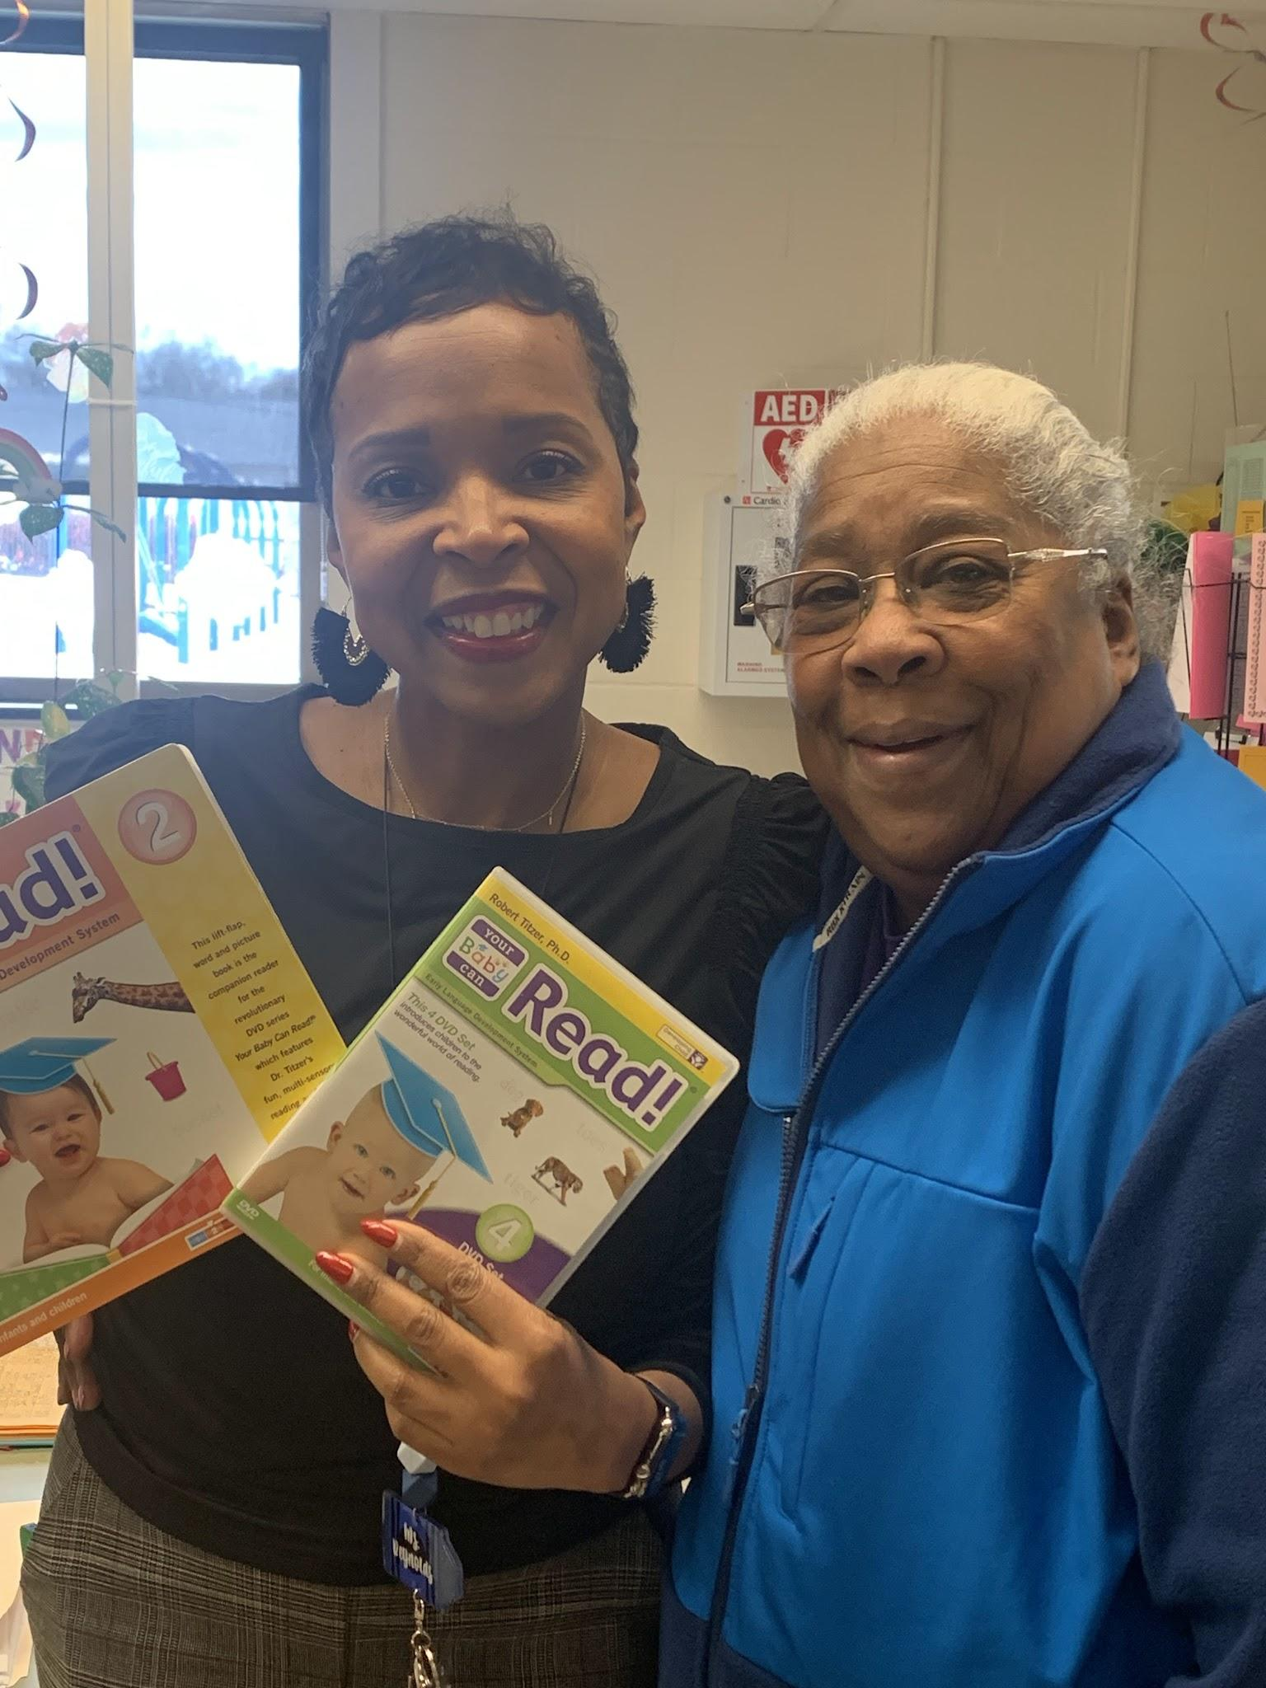
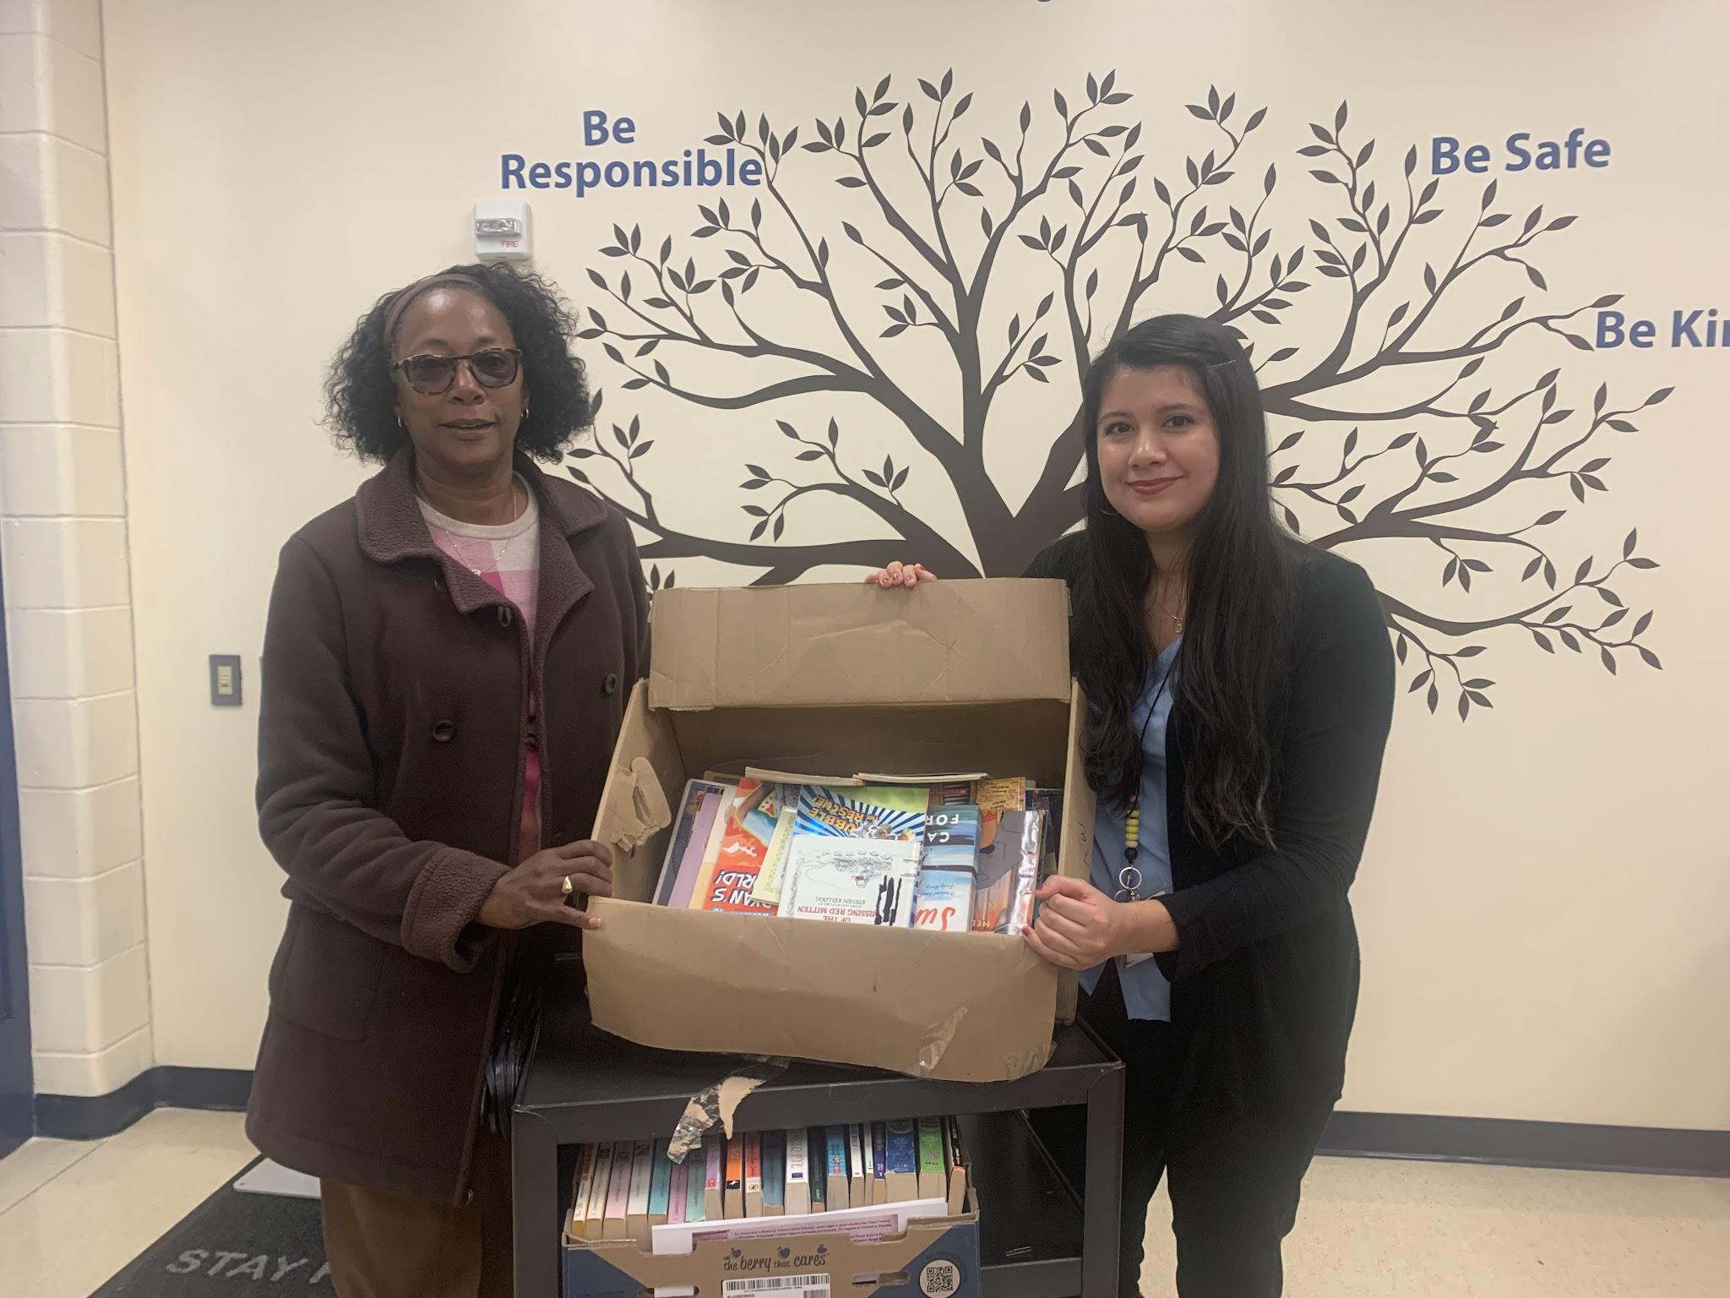

GETC Yard Sale
Our final GETC Yard Sale was held September 30th. The missionaries were busy working and organizing items for the sale. Free pampers and books were available. We were blessed to have a good sale and add to the missionary fund.

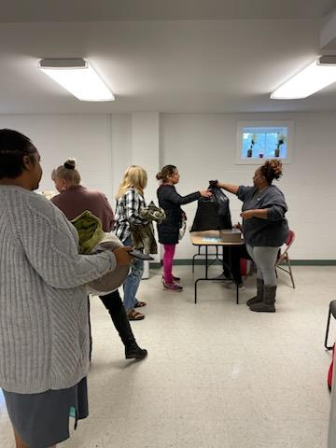

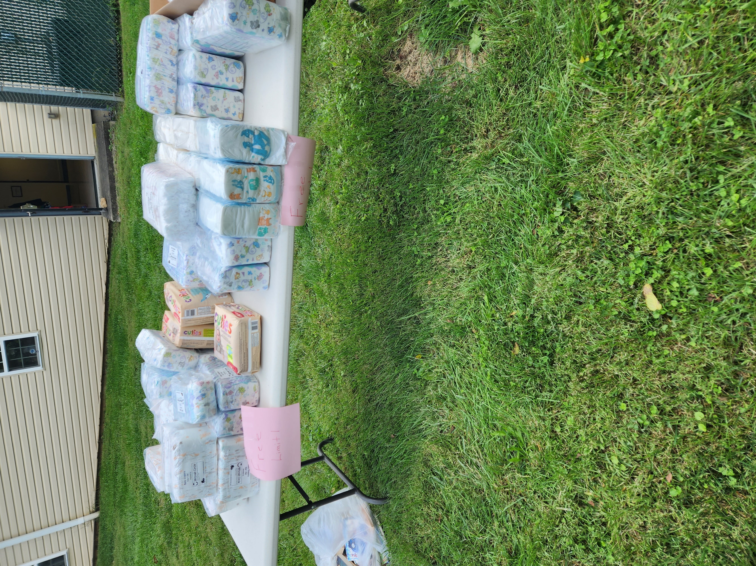

Health Fair
Missionary Dr. Stewart is a member of the Newark, Delaware NAACP Health/Environmental Justice Committee. She attended a health fair in Newark,DE. The NAACP group did blood pressure checks and handed . out literature on the importance of drinking water, lead in water and NAACP membership .

GETC continues to donate items to our global missions. We support on a monthly basis. Upendo United Foundation, Inc., which is a non-profit 501 ©3 organization based in Newark, Delaware and Nakuru, Kenya. We donate money to help ship items to Kenya, such as boxes of diapers of assorted sizes, books, feminine products, and clothing. Check out the website www.upendounitedfoundation.org.

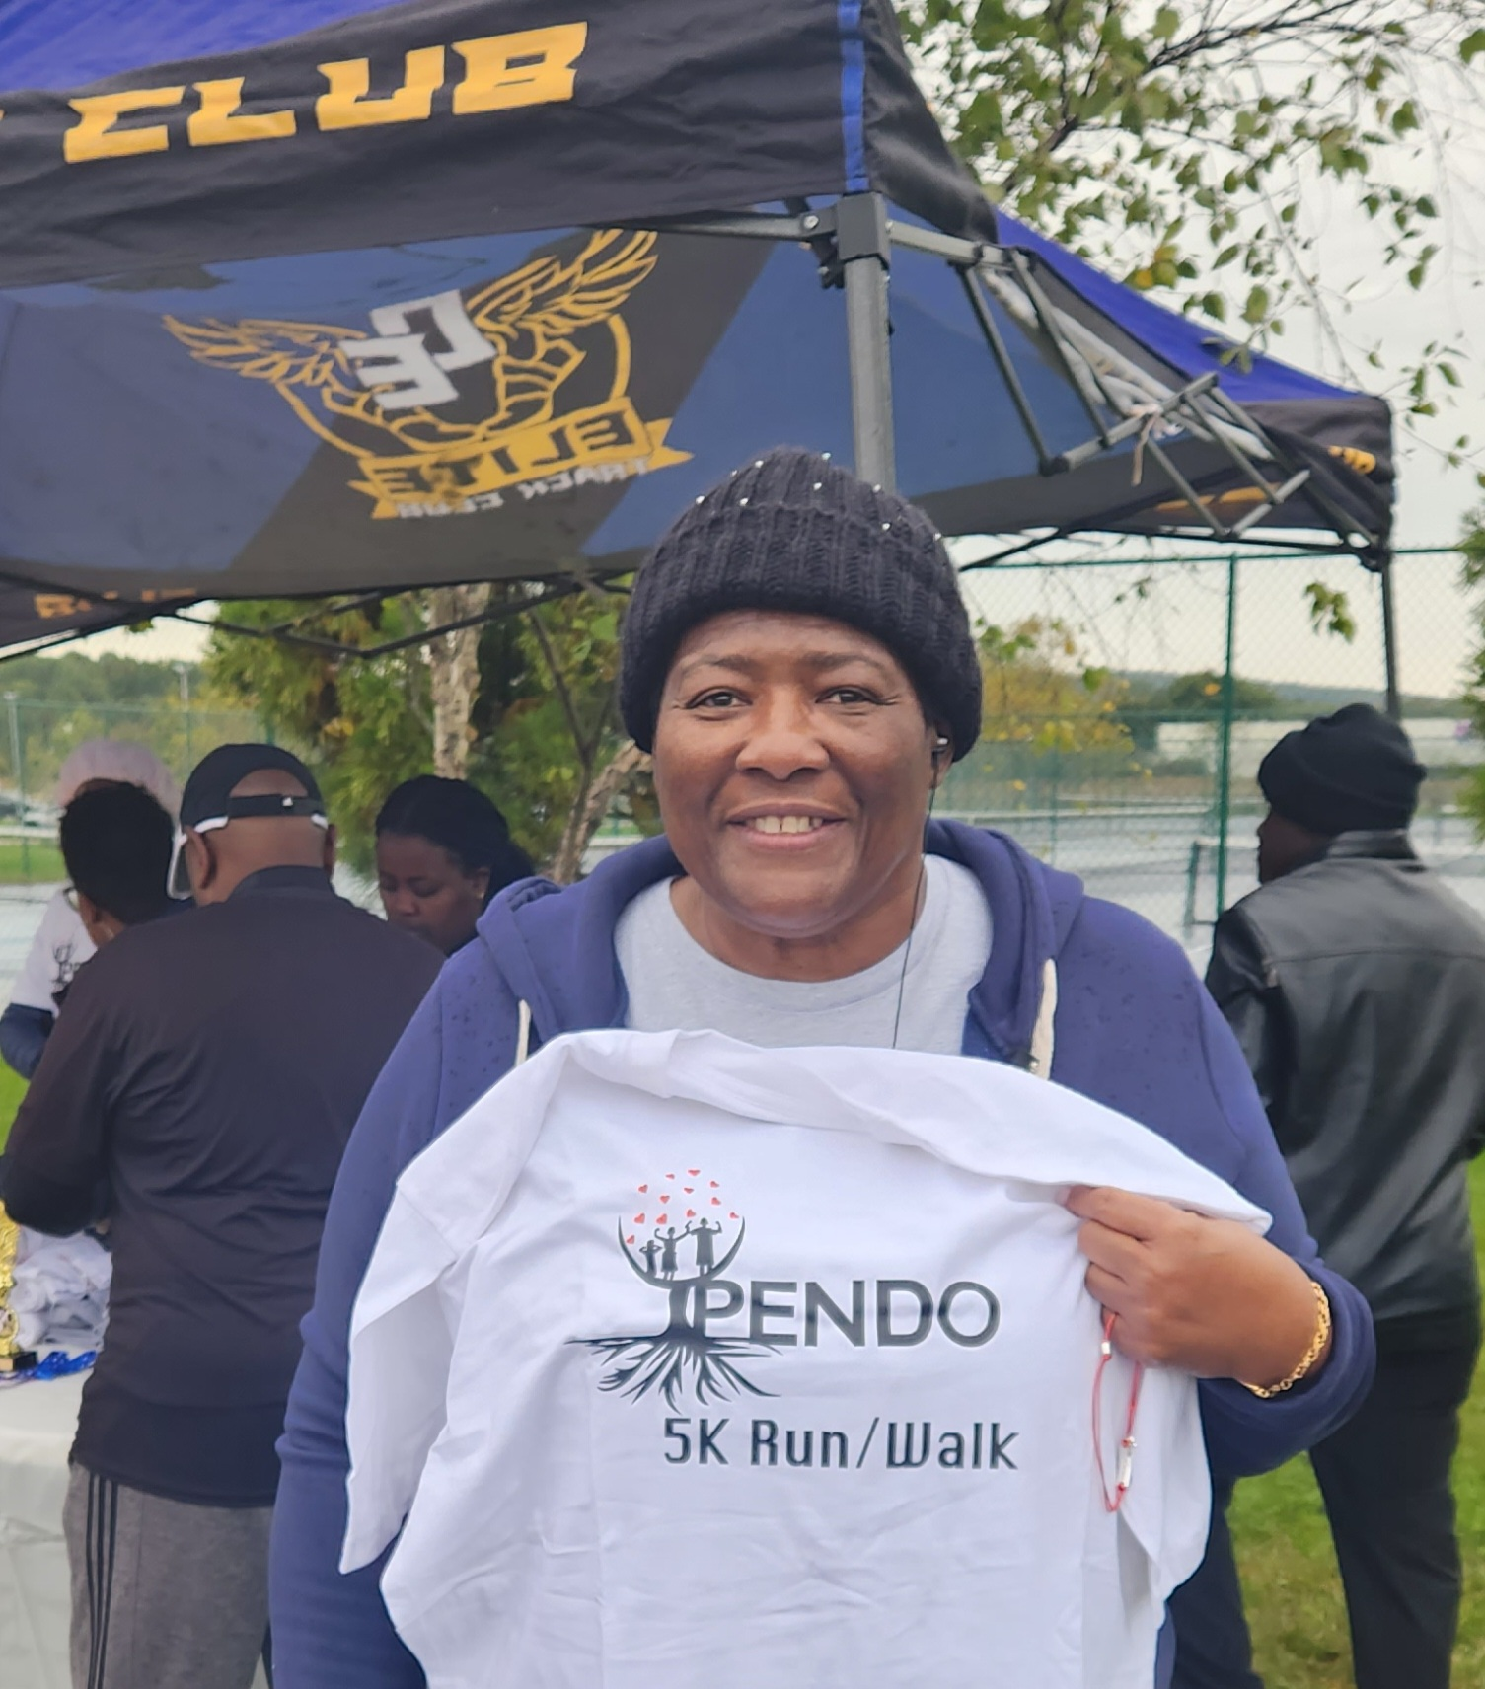
Missionary Dr. Shirley Stewart participated in the 5K walk at Glasgow Park in Newark, Delaware.

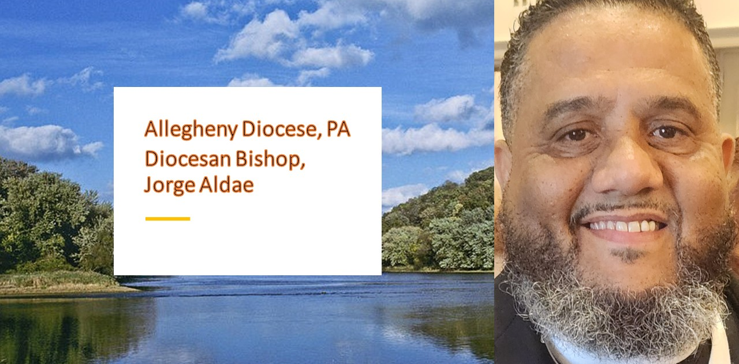
Jr. Missionary Dr. Kristina Washington

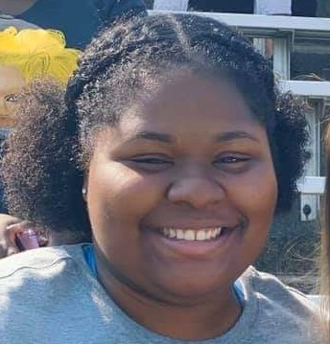

On November 27th, Dr. Washington successfully defended her dissertation: Context Matters: Examining the Impact of Context on Youth’s Mental Health and School Functioning Within an Incarcerated Population”. As her mentor, I was immensely proud as she presented her paper via Zoom. Families and friends watched, prayed, and celebrated her new title-Kristina Washington, Ph.D.
Dr. Washington is completing her internship in the trauma unit at Yale University. We, the GETC Missionary Department miss her at church and are soliciting your prayers for her continued success.





to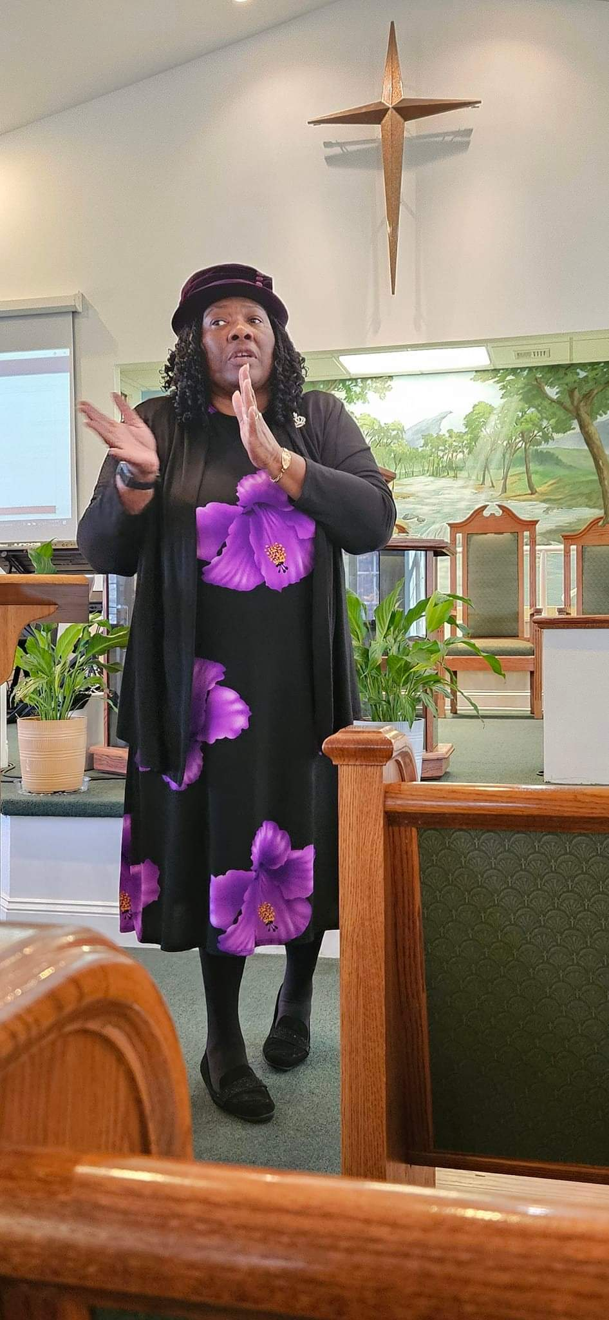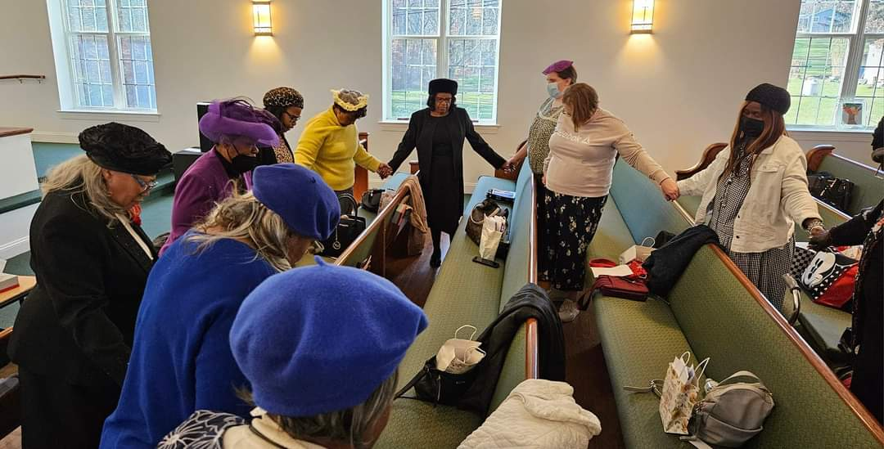 see it before we can shape it into reality. From a Christian

Revisiting the Vision.”
Stephen Covey’s definition of vision was shared as the impetus for group discussion about personal visions and the vision for our churches.
Steven Covey has written, “All things are created twice.” First there is the mental creation and then the physical creation. Vision pertains to this first creation. We have to see it before we can shape it into reality. From a Christian
.
On November 19th, The Allegheny Diocese meeting was held at Greater Emmanuel Temple Church. There were youth, men, and women’s sessions. GETC Missionary President Dr. Shirley Stewart was the presenter for the women. Her session was interactive. The topic was in line with Bishop Aldae’s vision for the diocesan churches. Dr. Stewart’s session was entitled: “Casting, Sharing and Revisiting the Vision.”

. perspective, vision is the ability to clearly see and articulate where God wants us to go or what God wants us to do in a given situation. Vision is the bridge between present and future reality. As one man stated, “If you want to find a needle in a haystack it is almost impossible. Yet if you place a magnet on the edge of the haystack, the needles jump out.” Vision is that magnet that attracts followers and resources.”

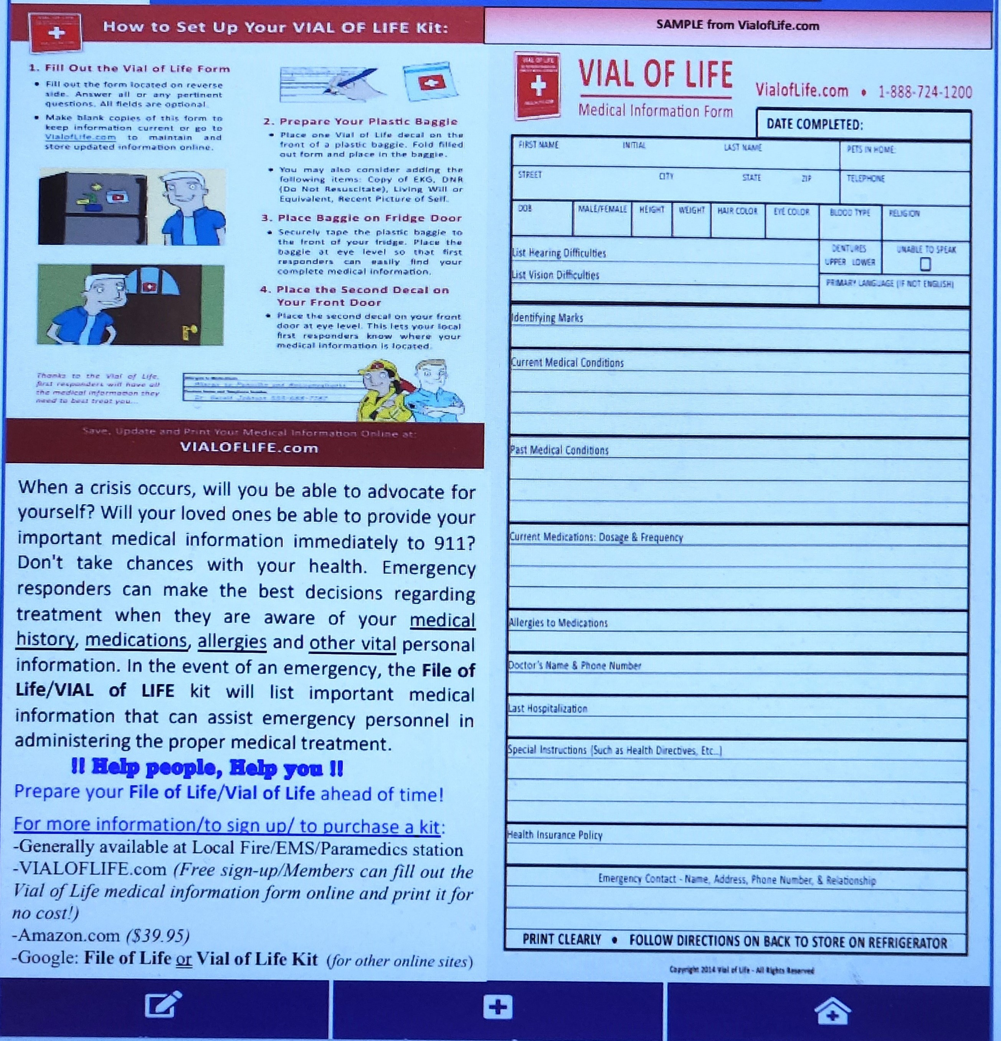
Vial For Life

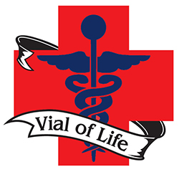
https://www.vialoflife.com/wp-content/uploads/2022/05/VOLFORM2022May27.pdf
Thanks for sharing this vital information, Missionary Debra Brown.



Greater Emmanuel Temple Church
296 Pemberton Road
Kennett Square, PA 19348
Phone 610-444-4504
Missionary Email: getcmissionary296@gmail.com
Church website: www.greateretc.org

Services

Tuesday Night Virtual Bible Study @ 7 PM

Sunday School for all Ages @ 9:30 AM

Morning Worship @ 11 AM

Missionary Dr. Shirley Stewart facilitates our GETC Book Club. Our last book of the year was When God Whispers Your Name by Max Lucado. It was an awesome read. It was hands down our favorite book of the year. We spent several sessions discussing various segments of the book. His writing style is unique and causes the reader to self-reflect. Join us in January for the next book!

Upcoming Events

- January 6th, Bowling Fellowship at Timber Lanes -12 NOON
- Third Saturday Prayer-January 20th February 17th, March 16th
10 AM-12 Noon
- Black History Month-Did You Know? Every Sunday in February
- February 21, 2024-Read Aloud in recognition of I Love to Read Month
- Women’s History Month-Did You Know? Every Sunday in March

