
The missionaries are excited to partner with the Upendo United Foundation. This foundation was started by Regina Reithii. Regina recently started this foundation to support an orphanage in Kenya which helps one hundred and thirty-five children ranging in age from 3 months to 19 years old. The missionaries will be supporting this home as a part of our global mission effort. Dr. Stewart delivered clothing, a game, books, stuffed animals, a computer monitor and writing tools to Regina’s home. Regina will be traveling to Kenya this month and will take some of the items with her. The rest will be shipped to the facility.
Upendo means “love “in Swahili. The core values of the organization are -love, connect, serve and give. Regina has set several goals to assist in meeting the needs of the children: build and maintain a library, establish a greenhouse, zero graze goats and cows and create a technical and trade program for the children. Please feel free to learn more about the foundation at www.upendounitedfoundation.org.
GETC missionaries will be supporting this orphanage on a monthly basis via goods and financial support. If you would like to support us in this endeavor, please send funds to Dr. Stewart by Cash App $SAS2036, PayPal-sstew63598@verizon.net. Please note funds for global missions.
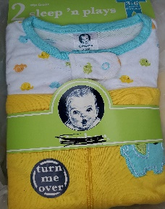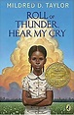
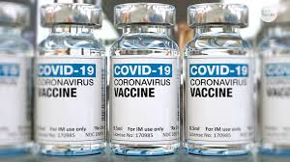
As of the writing of this newsletter more than 481,000 people have died in the United States of COVID and the research indicates that most of them are people of color. According to the Center for Disease Control African Americans and Hispanic die at a rate of over two and a half times more than whites. Of course, there are a myriad of reasons why this is the trend. Moreover, despite the availability of the vaccine, minorities tend not to get the vaccine. I would suggest that anyone unsure of the impact of the vaccine do their homework, ask their primary care physician or call their health insurance or state hotlines with questions about the vaccine. In January, COOLJC’s Department of Education held a highly informative townhall on COVID and the Vaccine. You can view the information presented at the following website: https://linktr.ee/COOLJC_COVID19. Call 1-877-724-3258 in Pennsylvania for information about COVID and for Delaware call 1-866-408-1899.

Missionary Spotlight
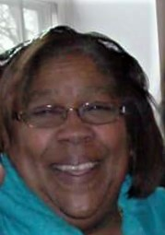
Missionary and First Lady of Greater Emmanuel Temple Church, Beverly L. Glasco is the eldest of the Cramer sisters. Her siblings, Brenda Wiley, Kathy Butler and Karen Middleton are affectionately known as the Cramer girls. Apostle William Cramer of Region IX, PA Diocese, is their father. He is the founder and senior pastor of GETC.
Missionary Glasco was born on September 1st in Pennsylvania. She is married to GETC’s pastor, Elder Wayne Glasco, Sr. They have four children and seven grandchildren.
Missionary Glasco has been a member of COOLJC for 53 years and GETC for 56 years! She serves as GETC’s choir director and she is a missionary. Formerly, she served as Young People’s President and Director of PA State Choir Director.
Missionary Glasco is a Goldey-Beacom graduate. She also is a certified special education paraprofessional and completed CNA course work at Delaware Tech.
Missionary Glasco has held several jobs, among the past employers were Pepperidge Farm, Laskos and Norcross. She also worked as a secretary at Lincoln University. She retired as a Paraprofessional from Kennett Square School District.
Her favorite color is blue. Her favorite scripture is Philippians 4 :13 – “I can do all things through Christ which strengtheneth me”. She likes crocheting and Find a Word puzzles. Her favorite food is lobster. Finally, Missionary Glasco’s “bucket list”: includes travel to the Grand Cayman Islands.
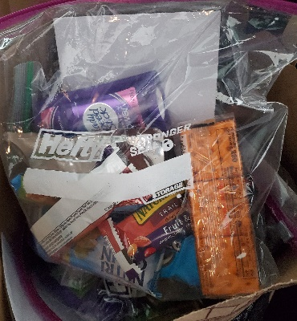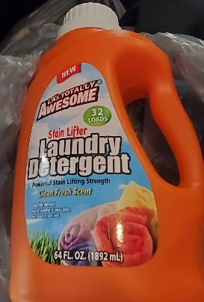
GETC Outreach
Many thanks to GETC for its generous outreach offering. The missionaries were able take “blessings packages” to 22 clients at the Chester Salvation Army. Above is a photo of the bags we prepared. Each one contained deodorant, snacks, juice, water, a daily bread, a Christmas card, socks, toothbrushes, toothpaste, and face masks. Each individual also receive a bottle of detergent as well. Extra bags were distributed to others in need.

Missionary Lineada Smith has partnered with Mitzvah Circle. Through this organization she was able to obtain pampers of all sizes, baby and feminine products. These items are distributed on a monthly basis.
Food insecurity is a real issue during this pandemic. Missionary Lineada Smith continues to collect all types of food boxes to distribute to members of her community and church. We applaud Missionary Smith for giving of her time and finances to make this sacrifice. She has a heart for helping others in need at any time and any place. She embodies Proverbs 31:20 “She stretcheth out her hand to the poor; yea she reacheth forth her hands to the needy.”
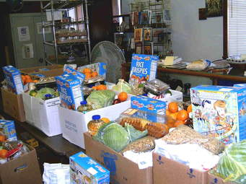
Dr. Stewart instituted Operation Smile in May. It is an ongoing campaign to encourage people unable to attend services or confined to their homes or facilities. Operation Smile involves a letter and or card campaign for any resident in a health facility, especially nursing homes or centers for the elderly. Our major goal is to bring a smile to the clients at these institutions. Missionaries were given a list of saints and organizations to send cards of inspiration and encouragement. Correspondence is also mailed out to residents at Churchman Village in Newark, DE, Arbour Square at West Chester in West Chester, PA, Fair Acres Geriatric Center in Media, PA, and Twin Pines Health Care Center in West Grove, PA. If you would like to add an agency on the list; please notify Dr. Stewart. No visitations are allowed due to COVID19 precautions. Many are in isolation. It is vital during this pandemic for the residents to know that they are not alone; we are praying for them and God is aware of their predicament.
Moreover, the missionaries send out cards and letters, make phone calls, send emails, post encouraging words on Facebook and other social media outlets. Our missionary president, Dr. Stewart, also posts Words of Encouragement on Facebook, Instagram, Twitter and shares inspirational quotes and devotionals with the missionaries and others via text or an email. Missionary Beverly Glasco post Monday Messages of Encouragement via text as well. In addition, many missionaries participate in ZOOM, YouTube, Facebook Live and other platforms for church services, bible studies and prayer meetings.
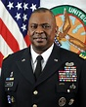
Our Black History moment recognizes Lloyd J. Austin III. He hails from Mobile, Alabama. At the age of 67, he is the first black Secretary of Defense of the United States. He was sworn in on January 22, 2021. General Austin is a graduate of the U.S. Military Academy at West Point, N.Y. He served 41 years in the uniform, retiring as a four-star Army general after serving as commander of the United States Central Command.
